Safe Exam

[What is SAFe? | Atlassian](https://www.atlassian.com/agile/agile-at-scale/what-is-safe#:~:text=The%20Scaled%20Agile%20Framework%C2%AE,agile%20practices%20at%20enterprise%20scale.&text=SAFe%20promotes%20alignment%2C%20collaboration%2C%20and,large%20numbers%20of%20agile%20teams.)

[SAFe 5 for Lean Enterprises](https://www.scaledagileframework.com/)

[SAFe 5.0 Overview in Five Minutes](https://www.youtube.com/watch?v=aW2m-BtCJyE)

[Scaled Agile Framework (SAFe) Tutorial | SAFe Agile Framework Tutorial | Introduction to SAFe Agile](https://www.youtube.com/watch?v=prlzeOQhHmg)

[SAFe Glossary - Scaled Agile Framework](https://www.scaledagileframework.com/glossary/)

[Sample Questions - All SAFe® 5 Certifications - SAFe® 5 Product Owner/Product Manager | Rise 360](https://rise.articulate.com/share/AzITXNj_0Pe_Cm8TogNWBaJ5l4sjm6o3#/lessons/I4C5pnbJaVGnG9fuOD6U-aWhsCIUcLFa)

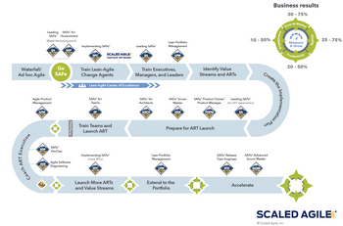

(Implementation - Scaled Agile Framework)

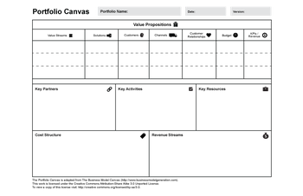

(Portfolio Vision - Scaled Agile Framework)

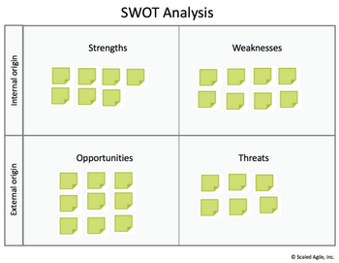

(Portfolio Vision - Scaled Agile Framework)

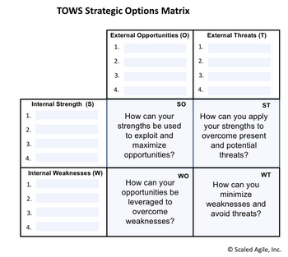

(Portfolio Vision - Scaled Agile Framework)

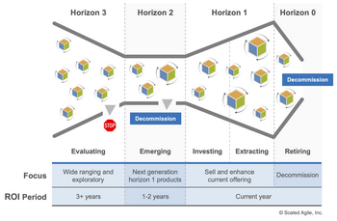

(Lean Budgets - Scaled Agile Framework)

(Sample Questions - All SAFe® 5 Certifications - SAFe® 5 DevOps Practitioner | Rise 360)

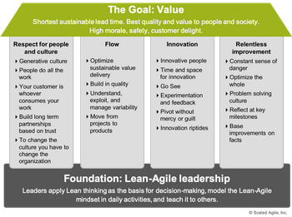

(Lean-Agile Mindset - Scaled Agile Framework)

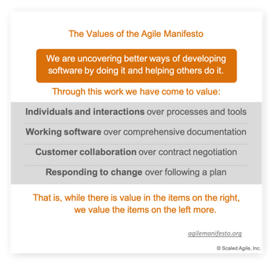

(Lean-Agile Mindset - Scaled Agile Framework)

[Agile Principles Explained | Agile Manifesto | 12 Agile Principles | Knowledgehut](https://www.youtube.com/watch?v=jSayJF0epJs)

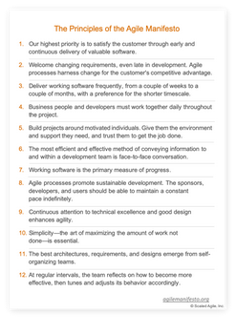

(Lean-Agile Mindset - Scaled Agile Framework)

[Implementation - Create a Lean-Agile Center of Excellence - Scaled Agile Framework](https://www.scaledagileframework.com/LACE/)

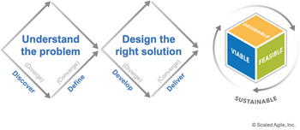

(Design Thinking - Scaled Agile Framework)

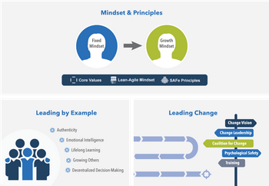

(Lean-Agile Leadership - Scaled Agile Framework)

References

*Design Thinking - Scaled Agile Framework*. Retrieved January 19, 1970, from https://www.scaledagileframework.com/design-thinking/

*Implementation - Scaled Agile Framework*. Retrieved January 19, 1970, from https://www.scaledagileframework.com/implementation-roadmap/

*Lean Budgets - Scaled Agile Framework*. Retrieved January 19, 1970, from https://www.scaledagileframework.com/lean-budgets/

*Lean-Agile Leadership - Scaled Agile Framework*. Retrieved January 19, 1970, from https://www.scaledagileframework.com/lean-agile-leadership/

*Lean-Agile Mindset - Scaled Agile Framework*. Retrieved January 19, 1970, from https://www.scaledagileframework.com/lean-agile-mindset/

*Portfolio Vision - Scaled Agile Framework*. Retrieved January 19, 1970, from https://www.scaledagileframework.com/portfolio-vision/

*Sample Questions - All SAFe® 5 Certifications - SAFe® 5 DevOps Practitioner | Rise 360*. Retrieved January 19, 1970, from https://rise.articulate.com/share/AzITXNj_0Pe_Cm8TogNWBaJ5l4sjm6o3#/lessons/wr6DuMxTPFf1njDQxDl9M5BbGN7ziQH9:~:text=Lead%20process%20time,by%20lead%20time